- BACKGROUND
Institut Keusahawanan Negara Berhad (INSKEN) is an agency under the purview of Ministry of Entrepreneur Development and Cooperatives (KUSKOP) that offers entrepreneurship development initiatives through its capacity and ecosystem building programmes.

In line with INSKEN’s tagline, “Membangun Usahawan Madani”, INSKEN ensures all programmes conducted are based on industry need. The programmes will be executed through smart collaboration with industry practitioners, professionals and government agencies to strengthen the national entrepreneurship ecosystem.

Vision
Realizing the National Entrepreneurship aspiration through capacity building of entrepreneurs with outcomes

Mission
- Strengthening the entrepreneurial development ecosystem by measuring outcomes.
- Enhancing an entrepreneur’s ability to be resilient, competitive and global.
- Encouraging collaborations between Ministries, Agencies and Industries.
- Preparing entrepreneurs to be catalysts and leading trends and markets.

- SCOPE OF WORKS
INSKEN is soliciting proposals from qualified service providers(s)/consultant(s) to propose efficient frameworks and oversee the delivery of BANGKIT: Keusahawanan Sosial (SE)

BANGKIT: Keusahawanan Sosial (SE) is a testing and acceleration space for existing and potential social entrepreneurs (SE) to create, test and refine innovative solutions. Through expert mentoring, participants develop high impact prototypes capable of addressing social and economic challenges.

Summary of BANGKIT: Keusahawanan Sosial (SE) is as follows:

OBJECTIVE | - Advancing the Accreditation Level of Social Enterprises  To facilitate the SEs in getting and upgrading their accreditation status to the next level i.e non-accredited to Aspiring, Aspiring to SE. Basic, SE. Basic to SE. Accredited.  - Strengthening the Capacity and Sustainability of Social Enterprises  To enhance the business, operational, and governance capabilities of social enterprises, enabling them to achieve financial sustainability while delivering measurable social impact.  iii. Developing Investment-Ready and Scale-Ready Social Enterprises  Preparing high-potential SEs for growth through structured acceleration, mentorship, and exposure to funding, partnerships and market opportunities.
SCOPE OF WORK & KEY PERFORMANCE INDICATORS (KPIs) | - Propose suitable criteria for the participants other than what have been pre-determined by INSKEN  - Facilitate promotion of the programme to obtain applications  - Other relevant scopes that facilitate the application process.  - Oversee the briefing and interview session  - To be the main secretariat responsible to ensure all parties involved are followed through and communicated effectively  - Develop suitable scoring methods for panelist in the relevant stages  - Conduct due diligence on all submitted documents to ensure it is sufficient for evaluation, legal and in accordance with local laws and ensure information provided are correct based on best practices.  - Evaluate each application based on the criteria set.  - Present to INSKEN the shortlisted applicants (Target: Up to 15 companies/cohort)  - Identify the eligible top 5 from each cohort after Demo Day to receive further facilitations/interventions from INSKEN  - Propose relevant modules – theoretical and practical activities for the applicants  - Ensure maximum engagement from both trainers / coaches and participants Coordination of schedules  - Prepare all documentation deemed necessary  - Submit monthly report and final report to INSKEN  - Other relevant scopes deemed necessary
SERVICE PROVIDER’S CRITERIA | - May be an individual / academia / registered business / consultant  - Proven record in conducting accelerator programmes / training / coaching / capacity building / event management, preferably in social entrepreneurship realm  - Is currently active and willing to assist, guide and develop participants (entrepreneurs) and entrepreneurship ecosystem  - Has good business sense
PROGRAMME MODE | Physical & Online
DURATION | Up to 4 months
PROGRAMME COMPONENTS | - Phase 1: Outreach and Promotion  - Phase 2: Selection/Interview  - Phase 3: Accelerator (8 weeks – alternate theoretical and practical)  - Phase 4: 4 Mini Demo Day & 1 Grand Demo Day  - Phase 5: Post-Programme Interventions
TIMELINE | Rendering of services to commence immediately upon appointment – 2026 onwards (each cohort would take up to 4 months)
Table 1: Summary of services required from the appointed consultant

BANGKIT: SE FRAMEWORK

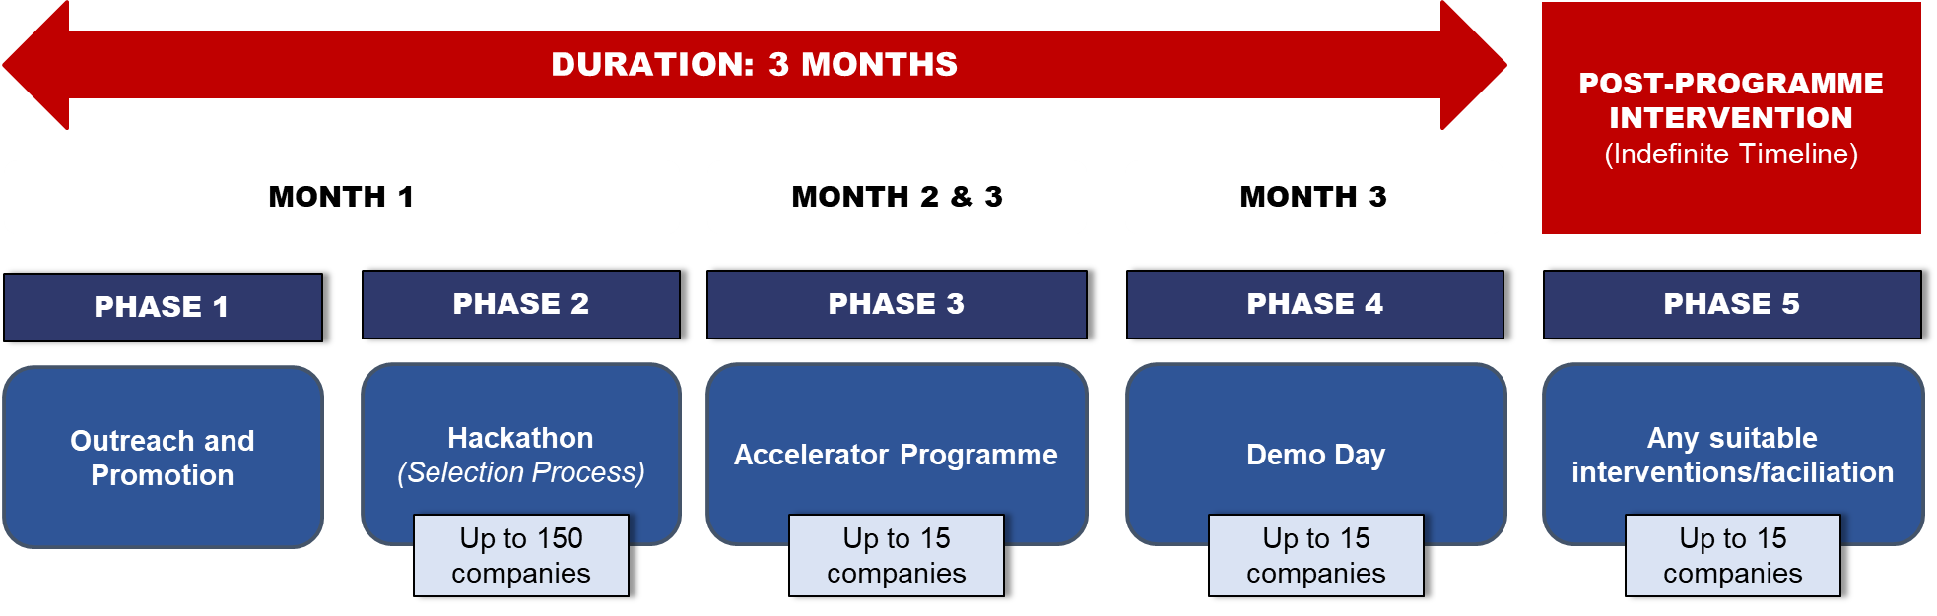

- COPYRIGHT OF PRODUCTS AND/OR DELIVERABLES
Service provider(s) shall acknowledge and agree that any products and/or deliverables created for the purpose of this RFP shall be considered as a “work made for hire” and all rights to the said products and/or deliverables shall belong exclusively to INSKEN. Service provider(s) shall be prohibited from disseminating products and/or deliverables developed and funded under this service to other parties without prior consent from INSKEN.

- TIMELINE
The RFP process will be conducted as per the schedule below:

No | Activity | Proposed Dates*
1 | Issuance of RFP Document | 8 February 2026
2 | RFP Promotion | 11 February 2026
3 | Deadline to register for RFP Briefing | 16 February 2026
4 | Briefing on RFP Document | 23 February 2026
5 | Deadline for Submission of Proposal(s) | 27 February 2026
6 | Selection of Service Provider(s) | Feb – March 2026
7 | Proposal Pitching | March 2026
8 | Appointment of Service Provider(s) | March 2026
*Notes: Subject to change
Table 2: Timeline of RFP process until appointment

Should the submitter(s) not receive any response from INSKEN within one(1) month from the submission date, the application is considered to be unsuccessful. INSKEN reserve to hold the proposals submitted for referencing purposes.

- CONTENT OF THE PROPOSALS
All proposals must include the following information:

PART | REQUIREMENTS
A | Company profile & credentials and consultant profiles including team’ profile. (Please limit to maximum of 3 pages)
B | - Compliance to Scope of Work as per stipulated in Table 1  - Propose modules/topics for each component in BANGKIT:SE  - Other relevant input deemed important  (Please limit to maximum of 6 pages)
C | Costing breakdown by components covering programme delivery, programme evaluation and management, report development and other applicable fees  (Please limit maximum 1 page)
Table 3: Content of the RFP document

Total Maximum page for RFP : 10 pages ONLY
The “Sample of Proposal” can be downloaded at the following link, www.insken.gov.my/rfp. Please submit your proposal via online submission using the provided template and email to rfp@insken.gov.my with the header as follows: • BANGKIT:SE 2026 Vendor Proposal – xxxxx Sdn. Bhd.
- REVIEW AND SELECTION
The selection panel will review the proposals based on the following
criteria:

NO | CRITERIA | PERCENTAGE
1 | ORGANISATIONAL INFORMATION  Experience of the company and company profile – turnover of the company, manpower and its success stories, recognition (testimony). | 20%
2 | CONSULTANCY SERVICES  Detailed information on the phases, including its technical workflow and scope delivery, as stipulated in Table 1 | 60%
3 | BUDGET  Detailed costing and other information to support the proposed scope of works (items to include details as the consultancy services fee, out of pocket expenses, report development fee, evaluation fee and other applicable fees. | 20%
TOTAL |  | 100%
Table 4: Criteria/content framework of the proposal

Only shortlisted Service provider(s) will be contacted and may be required to present their proposals to the selection panel.

- ADMINISTRATIVE MATTERS
Companies interested in participating in the Request for proposal (RFP) process must attend the briefing session as per scheduled in the timeline in Section 4 (Table 2) OR other dates that will be informed by INSKEN.

In order to register and receive the invitation to the briefing session, please email to rfp@insken.gov.my to register for RFP briefing (refer to Timeline in Section 4 – Table 2). Please state your name, company, phone number and mention your interest to attend the briefing session. Invitation or Links to the Zoom / Google Meet session will be given only to registered companies.

INSKEN will not entertain inquiries via email or phone calls. All questions will be answered during the briefing sessions only.

INSKEN reserves the right to accept or reject any or all proposals received, to negotiate with any qualified proposer, or to cancel in part or in its entirety this RFP process if it is in its best interest to do so without giving any reason whatsoever. This RFP does not commit INSKEN to award funding or pay any cost incurred in the preparation of the proposal.

END OF DOCUMENT

