INSTITUT KEUSAHAWANAN NEGARA
REQUEST FOR PROPOSAL FORMAT

VENDOR FOR DEVELOPMENT OF BANGKIT: KEUSAHAWANAN SOSIAL (SE) 2026

PART A : COMPANY PROFILE
Company Name | :
Registration No | :
Year Incorporated | :
Type of Business Activity | :
Industry | :
Address & Phone No | :
Shareholder(s)/ Partner(s) & Highest Academic Qualifications & Working Experience | : | Name  Education  Position  Experience
Lead Consultant, Assistant Consultants Line up & Specialisation,  Highest Academic Qualifications & Consultancy Experience | : | - Name  Education  Position  Experience  - Name  Education  Position  Experience
Last year turnover | : | RM XXXX
Full Employee(s) | : | XX employees
Experience in industry | : | XX years
Experience in consultancy services | : | xx years
Track Record | :

PART B : SCOPE OF WORK
Please outline, with technicalities, on the proposed approach and delivery of each scope of work as stipulated in the table below. Please utilize table format to ensure information are concise for ease of reference.

OBJECTIVE | - Advancing the Accreditation Level of Social Enterprises  To facilitate the SEs in getting and upgrading their accreditation status to the next level i.e non-accredited to Aspiring, Aspiring to SE. Basic, SE. Basic to SE. Accredited.  - Strengthening the Capacity and Sustainability of Social Enterprises  To enhance the business, operational, and governance capabilities of social enterprises, enabling them to achieve financial sustainability while delivering measurable social impact.  iii. Developing Investment-Ready and Scale-Ready Social Enterprises  Preparing high-potential SEs for growth through structured acceleration, mentorship, and exposure to funding, partnerships and market opportunities.
OUTCOME | ENTREPRENURS KPI:  At the end of the programme, a certain KPI need to be achieved:  - 300 participants were trained (through 4 cohorts)  - 10 corporates/organisations purchase from the entreprenurs (social procurement)  - A minimum of 10% participants enrolled in accelerator phase  - A minimum of 30% participants upgrade their SE accreditation status  SERVICE PROVIDER’S SCOPE OF WORK & KPI:  - Propose suitable criteria for the participants other than what have been pre-determined by INSKEN  - Facilitate promotion of the programme to obtain applications  - Other relevant scopes that facilitate the application process.  - Oversee the briefing and interview session  - To be the main secretariat responsible to ensure all parties involved are followed through and communicated effectively  - Develop suitable scoring methods for panelist in the relevant stages  - Conduct due diligence on all submitted documents to ensure it is sufficient for evaluation, legal and in accordance with local laws and ensure information provided are correct based on best practices.  - Evaluate each application based on the criteria set.  - Present to INSKEN the shortlisted applicants (Target: Up to 15 companies/cohort)  - Identify the eligible top 5 from each cohort after Demo Day to receive further facilitations/interventions from INSKEN  - Propose relevant modules – theoretical and practical activities for the applicants  - Ensure maximum engagement from both trainers / coaches and participants Coordination of schedules  - Prepare all documentations deemed necessary  - Submit monthly report and final report to INSKEN  - Other relevant scopes deemed necessary
SERVICE PROVIDER’S CRITERIA | - May be an individual / academia / registered business / consultant  - Proven record in conducting accelerator programmes / training / coaching / capacity building / event management, preferably in social entrepreneurship realm  - Is currently active and illing to assist, guide and develop participants (entrepreneurs) and entrepreneurship ecosystem  - Has good business sense
PARTICIPANTS’ CRITERIA | - At least one (1) Malaysian owner/director/top management  - Sustainable and scalable business model, with clear beneficiaries  - SE Accreditation is not a pre-requisite, but would be a bonus  - Other criteria shall be subject to INSKEN’s discretion
COHORT | 4 cohort
NUMBER OF PARTICIPANTS | - Up to 150 companies / cohort  - Only 15 companies / cohort will be shortlisted for the accelerator programme and demo day
PROGRAMME MODE | Physical & Online
DURATION | Up to 4 months
PROGRAMME COMPONENTS | - Phase 1: Outreach and Promotion  - Phase 2: Selection/Interview  - Phase 3: Accelerator (8 weeks – alternate theoretical and practical)  - Phase 4: 4 Mini Demo Day & 1 Grand Demo Day  - Phase 5: Post-Programme Interventions
TIMELINE | Rendering of services to commence immediately upon appointment targeted in March 2025 and the Grand Demo Day is scheduled for October 2025
Table 1: Summary of services required from the appointed consultant
BANGKIT: SE FRAMEWORK

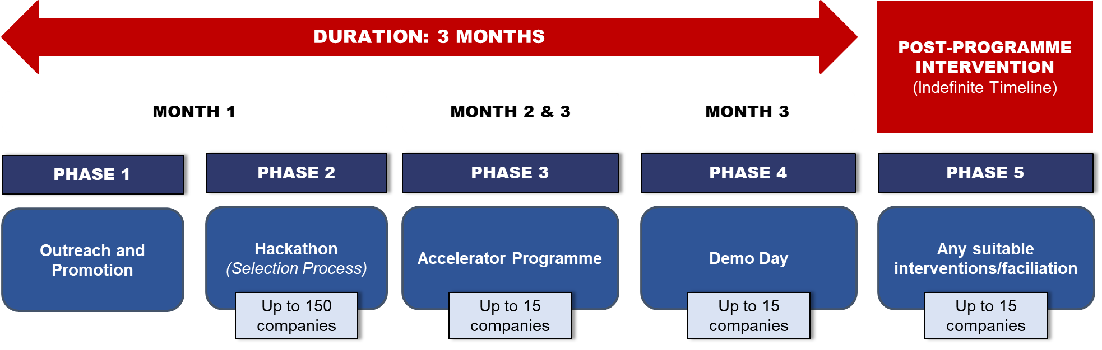

PART C : PROPOSED COSTING
NO | ITEM | UNIT
1 | Consultancy Services / Documentation Fee
2 | Reports Development Fee
3 | Evaluation Fee
4 | Out of Pocket Expenses
5 | Other Applicable Fees (Please outline each item under this category)
TOTAL RM
Note: The costing is subject to further negotiation

