INSTITUT KEUSAHAWANAN NEGARA
PROPOSAL TITLE : RFP2021/ET/IBT/SMOL1 rRFP2020/ET//SMOL1RFP2020/ET/IBT/SMOL1RFP2020/ET/IBT/SMOL1
REQUEST FOR PROPOSAL FORMAT

FOR E-BOARD E-MARKETPLACE TRAINING
PART A : COMPANY PROFILE (20%)
Company Name | :
Registration No | :
Year Incorporated | :
Type of Business Activity | :
Industry | :
Address & Phone No | :
Shareholder(s)/ Partner(s) & Highest Academic Qualifications & Working Experience | : | 1.
Trainers Line up & Specialisation,  Highest Academic Qualifications & Working Experience | : | - Name  Education  Position  Experience
- Name
Education
Position
Experience

Last year turnover (2018) | : | RM XXXX
Full Employee(s) | :
Experience in industry (consultants & trainers) | :
Experience in training | : | XX years
Track Record | : | Business to Consumer (B2C)  1.  2.  Business to Business (B2B)  1.  2.
PART B: PROGRAMME SPESIFICATIONS, TENTATIVE, INSTRUCTIONAL GUIDE & OUTCOMES (60%)
- PROGRAMME SPECIFICATIONS
Programme | : | E-Board E-Marketplace Training
Code | : | EB01
Mode | : | Training – Online (Virtual)
*Level (please stated based on proposed module) | :
Duration | : | 2 days
*Learning Objective (s) | : | Mandatory to cover 7 platforms of Facebook, Instagram, Whatsapp, Telegram, Youtube, Lazada, Shopee
Expected Outcomes (s) | : | Participants’ understanding of each platform - Facebook, Instagram, WhatsApp, Telegram, Youtube, Lazada, Shopee
*Target Participant | : | 50 pax/per session
 | :
*Pre requisite  (if any) | :
*Special requirements?
Module Content(s) | : | (Facebook, Instagram, Whatsapp, Telegram, Youtube, Lazada, Shopee)
Details Trainer/Coach/ Highest Academic & social media accounts (Linkedin, FB, & Instagram)  *please attached with trainers photo |  | Main Trainer/ Coach
 | : | 2nd Trainer/ Coach / Assistant  3rd Trainer/ Coach/ Assistant
Number of Team Members | :
*Make your pitch, why this module is important to entrepreneurs and how it can help/support them to improve their daily operations.  (Not more than 50 words & avoid generic pitches) | :

As a guideline for entrepreneurs, we recommend you to include (in the form of a road map as an example in page 5) to enable participants, to see clearly how your module will help them. Also what other related modules that will help them to complete the course.
EXAMPLE: PLANNING TIMELINE ROADMAP

GOAL:

Instagram to Promote Your Brand and Drive Sales

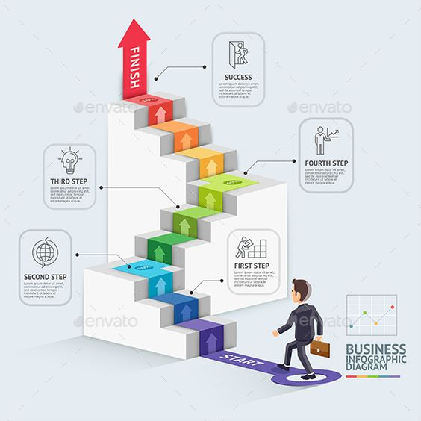
ADVANCED:

INTERMEDIATE:

BEGINNER/INTERMEDIATE:

BEGINNER:

- PROGRAMME TENTATIVE
*This programme tentative is just a guide. Any changes is subject to your actual module delivery
TIME | DAY 1 | DAY 2
0830-0900 am | REGISTRATION
0900-1000 am | SLOT 1 : | SLOT 8 :
1000-1030 am | BREAK | BREAK
1030-1130 am | SLOT 2 : | SLOT 9 :
1130-1230 nn | SLOT 3 : | SLOT 10 :
1230-0100 pm | SLOT 4 : | SLOT 11:
0100-0215 pm | LUNCH | LUNCH
0215-0330 pm | SLOT 5 : | SLOT 12 :
0330-0400 pm | BREAK | BREAK
0400-0530 pm | SLOT 6 : | SLOT 13 :
 |  | PROGRAMME END
0700-0800 pm | DINNER
0800-1030 pm | SLOT 7 :
1030-1100 pm
- INSTRUCTIONAL GUIDE
SLOT | TIME | DURATION | TITLE | LEARNING OUTCOME | ACTIVITY | MATERIAL
 | 0830-0900 am | 30 min | REGISTRATION
1 | 0830-0900 am | 30 min | Slot 1 :
2 | 0900-1000 am | 60 min | Slot 2 :
 | 1000-1015 am | 15 min | AM TEA BREAK
3 | 1015-0100 pm | 195 min | Slot 3 :
 | 0100-0215 pm | 75 min | LUNCH
4 | 0215-0330 pm | 75 min | Slot 4 :
 | 0330-0345 pm | 15 min | PM TEA BREAK
5 | 0345-0530 pm | 135 min | Slot 5 :
 | 0700-0800 pm | 120 min | DINNER
6 | 0800-1030 pm | 150 min | Slot 6 :
7 | 0830-0900 am | 30 min | Slot 7 :
8 | 0900-1000 am | 60 min | Slot 8 :
 | 1000-1015 am | 15 min | AM TEA BREAK
9 | 1030-0100 pm | 180 min | Slot 9 :
 | 0100-0215 pm | 75 min | LUNCH
10 | 0215-0330 pm | 75 min | Slot 10 :
 | 0330-0345 pm | 15 min | PM TEA BREAK
11 | 0345-0530 pm | 135 min | Slot 11 : |  | - Pre Post Test  - Evaluation Form
 |  |  | End of the Session
PART C : PROPOSED COSTING (20%)
NO | ITEM | COST PER UNIT (RM) | UNIT | TOTAL COST (RM)
1 | Training Delivery Fee
2 | Training Materials - Workbooks and equipment
3 | Assistants Cost
Total RM
Cost per head RMXXX
Note: The costing is subject to further negotiation

